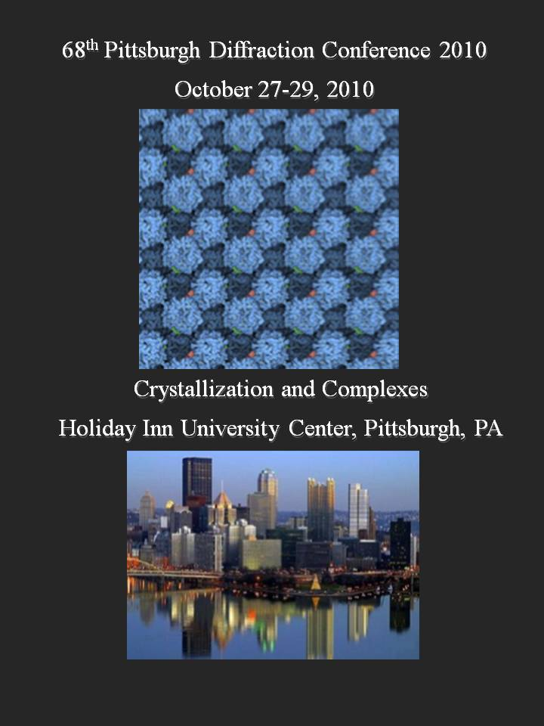

W

We are grateful to our sponsors

Schedule
PRESENTATIONS

PLENARY TALK

Promoting Crystallization by Increasing and Enhancing Intermolecular Interactions

Alexander McPherson

Dept. of Molecular Biology and Biochemistry
University of California, Irvine
Irvine, California, USA

An alternative approach to promoting the crystallization of proteins is to enhance intermolecular contacts between macromolecules, or to eliminate intermolecular interactions or interactions with solvent that might inhibit crystallization. Site-specific mutations have been employed, as have truncations by genetic or proteolytic means. There are, however, significant problems. Because the structure of the target macromolecule is unknown, there may be no good basis for the design of mutants or truncations. In addition, the approach requires that the protein be produced by recombinant DNA technology, which is frequently not the case. We have attempted to address these issues by initiating experiments based on two ideas. The first is that a wide variety of conventional small molecules might be systematically introduced into mother liquors during crystallization screening. By incorporation into the crystal lattice, the additional intermolecular interactions that the small molecules provide might enhance crystal nucleation and growth. A second approach that we are pursuing is the chemical modification of various amino acid side chains using traditional protein chemistry. We believe that in some cases chemically modified proteins might be induced to crystallize, or crystallize better than the native protein.

Visible Fluorescence Intensity-based Crystallization Screening Image Analysis

Marc Pusey
iXpressGenes Inc., 601 Genome Way, Huntsville, AL 35806.

High throughput screening for protein crystallization conditions results in large numbers of screening plates, the results of which need to be reviewed on a periodic basis. Manual reviewing of large numbers of plates can be a mind-numbingly tedious process. In line with robots for setting up plates robots have also been developed for imaging the results thereof, in some instances giving a rudimentary score of those results (crystal, clear, precipitated). Finding crystals in a solution using software has typically involved methods of first defining the solution (search field) boundaries, then looking for objects within those boundaries which have straight lines. We have previously advocated the use of trace fluorescent labeling, defined as <0.1% of the molecules being covalently labeled, as a means of rapidly identifying protein crystals when manually reviewing crystallization plates. Crystals, being the most concentrated solid phase form, will fluoresce more brightly than amorphous precipitate or clear solutions. We are now extending this approach to an automated system for imaging and subsequently scoring crystallization plate results. Rather than search for straight lines the software generates a histogram of intensity vs. number of pixels of that intensity, defines a threshold value based on the histogram, then puts forth a thresholded image showing pixels above this value. Preliminary tests show that the analysis process can find crystals in clear solution and when obscured by precipitate, with an image processing time of <0.5 seconds. Previous data has also shown that precipitated outcomes may have ‘bright spots’ which may be indicative of being optimizeable to crystallization conditions. Analysis software that can find such conditions could expand the numbers of lead conditions per screening trial. Additionally, we propose that by using multiple colors this approach may be useful in the crystallization of complexes.
The Application of High-throughput Technologies to Structural Studies
Edward H. Snell, Joseph R. Luft, George DeTitta and the staff of the Center for High-Throughput Structural Biology, Hauptman Woodward Medical Research Institute, Buffalo, NY 14203, USA.
The high-throughput crystallization screening facility at the Hauptman-Woodward Medical Research Institute has been operating for over 10 years and amassed data on crystallization experiments of over 12,000 proteins. This data includes over 120 million time-resolved images and where success and failure is measured over 20% of the samples submitted result in a structural deposition in the PDB. Recently we have become focused on a two basic questions: Why do 80% of the proteins that come to the lab fail to provide structures? What biochemical and biophysical properties can be used to distinguish and improve the success of these failures? We have expanded our high-throughput technologies to incorporate complementary X-ray and other biophysical techniques. We have coupled these characterizations with developments in image analysis. Our goal is to use these methods to improve the success of future structural studies by more fully characterizing and understanding the outcomes of previous ones. In this talk we will present these complimentary technologies, explain how we are meshing them together to globally describe the landscape to gain a more coherent understanding of the problem than any of the separate data could provide and how we are using high-throughput technologies to aid fundamental research. In particular we touch on the application of these developments to complex systems and describe where we plan to head for the next 10 years of our crystallization efforts.

SIDU AWARD PRESENTATION

Novel Hydrogen Storage Materials and Related Structural Studies

Hui Wu
NIST Center for Neutron Research, National Institute of Standards and Technology,
Gaithersburg, MD 20899-6102
Department of Materials Science and Engineering, University of Maryland,
College Park, MD 20742-2115

Successful development of hydrogen as a primary fuel will simultaneously reduce the dependence on fossil fuel and emissions of greenhouse gases and pollutants. This is especially critical in this century with increasing concern on energy security and global warming. Regarding hydrogen storage, one of the major challenges to widespread use of hydrogen is the lack of suitable hydrogen storage materials with the on-board operating storage capabilities for fuel-cell vehicular applications. In this talk, I will present some of our recent work on novel hydrogen storage materials including light-weight metal hydrides, chemical hydrides, and porous metal-organic frameworks (MOFs). I will focus on the structural studies of these materials with aspects of crystal structure determination of novel hydrides and the elucidation of adsorbed gas molecule location in MOFs, using x-ray or neutron powder diffraction method. The rich information obtained from the structural analysis and their implications for hydrogen storage will be discussed.
Large Volume Protein Crystallization for Neutron Crystallography

¹Joseph D. Ng, Ronny ¹Hughes, ²Leighton Coates,
³Matthew P. Blakely and ⁴Juan Manual Garcia-Ruiz

¹Laboratory for Structural Biology, University of Alabama, Huntsville,
²Oak Ridge National Laboratory,
³Institut Laue-Langevin, Grenoble France
⁴CSIC del Laboratorio de Estudios Cristalográficos, Granada, Spain

Neutron crystallography has been the leading method to obtain accurate positions of hydrogen atoms in biological structures of 50—175kDa with neutron data collected near atomic resolution (1.5 Å -2.5 Å). The biggest obstacle in neutron crystallography is obtaining large diffracting crystal volumes. Protein crystallization by counter-diffusion in restricted geometry is an effective technique to obtain large volume macromolecular crystals suitable for neutron crystallography. In counter-diffusion equilibration, the volumes of the precipitating agent and protein solution are arranged juxtaposition to one another inside an X-ray capillary tube. The two solutions are set to diffuse against each other resulting in a spatial-temporal gradient of supersaturation along the length of the capillary. Contrary to conventional techniques such as in vapor diffusion, varying supersaturation conditions leading to protein precipitation, nucleation and crystal growth can be obtained simultaneously in the capillary. Therefore, crystals obtained by this manner are a consequence of selective growth from different supersaturation environments. The application of the counter-diffusion crystallization method for neutron crystallography will be illustrated by novel hyperthermophilic proteins that have recently been grown to volumes exceeding 3mm^3. The strategy of crystallizing these proteins will be discussed with preliminary neutron crystallographic analyses performed at the Institut Laue-Langevin (source LADi III).

Neutron Diffraction and Data Analysis @ TOPAZ

Christina Hoffmann, Janik Zikovsky, Xiaoping Wang, Matt Frost
Neutron Scattering Sciences Division, Oak Ridge National Laboratory,
Oak Ridge, TN, 37831-6475

Neutron single crystal diffraction is a method complimentary to X-ray single crystal diffraction. It has the feature of being extraordinarily sensitive to light elements in the presence of heavy metals. This makes it an outstanding probe to determine the location of hydrogen in many materials from inorganic framework structures to organic molecular arrangements. Recent studies have shown that hydrogen is fundamental in determining function and stability of structures in inorganic and molecular compounds. Neutron and X-ray single crystal diffraction are most efficiently used as synergetic supplementary methods to receive structure information: the X-ray data provides the backbone or framework, whereas the neutron data provides the hydrogen and light element positions. Combining the refinements of neutron and X-ray data paint a comprehensive picture of the structure under investigation.

Laue neutron single crystal diffraction has proven to be an extremely powerful method to survey reciprocal space rapidly by simultaneously collecting Bragg reflections within a broad wavelength band or white beam. Using a pulsed neutron source – as is the case for TOPAZ at the Spallation Neutron Source at the Oak Ridge National Laboratory – allows for wavelength dependent recording of diffraction data in time-of-flight mode. This method is equally well suited for data collection of small molecules and macromolecular arrangements.

Neutron diffraction at the single crystal diffraction beamline TOPAZ has entered a friendly user phase. The installation of the basic components and development of software has proceeded to a stage where extended molecular arrangements can be investigated. TOPAZ is a highly versatile and accommodating single crystal neutron diffractometer. Data of weak scatterers with a large unit cell have been measured. Important steps towards an efficient data reduction and correction for instrument and sample effects have been implemented. A correction for spectrum, detector efficiency, instrument background effects will be implemented for all collected neutrons. A corrected intensity is used for integration. Sample absorption effects will be treated at Bragg peak integration.

This research is supported by UT Battelle, LLC under Contract No. DE-AC05-00OR22725 for the U.S. Department of Energy, Office of Science.

Glycerol and Oxidative Metabolism
Joanne I.Yeh,
Dept. of Structural Biology; Director, X-ray Crystallography

The sugar-alcohol, glycerol, is an essential source of energy that is required to help drive cellular respiration. In addition to powering some of the most central reactions of the body, glycerol also provides key precursors needed to regulate fatty acid and sugar metabolism. Fundamentally, biosynthesis of phospholipids and polysaccharide is regulated through the complex interplay between glycerol, carbohydrate, and fatty acid metabolic pathways. Moreover, glycerol metabolism impacts infectivity, virulence, and proliferation of pathogenic bacteria by providing the precursors for the synthesis of protective polysaccharides and lipids. Further clinical relevance of glycerol metabolic proteins is the identification genetic mutations that lead to diseases grouped under ‘inborn errors of metabolism’. Deciphering the complex mechanisms which cells break down or produce glycerol and use this vital metabolite by elucidation of their high-resolution three-dimensional structures can provide insights into structure-function and regulatory relationships. In this talk, the crystal structures of several glycerol metabolism proteins will be presented, with correlation of their three-dimensional structures to catalytic and regulatory mechanisms.
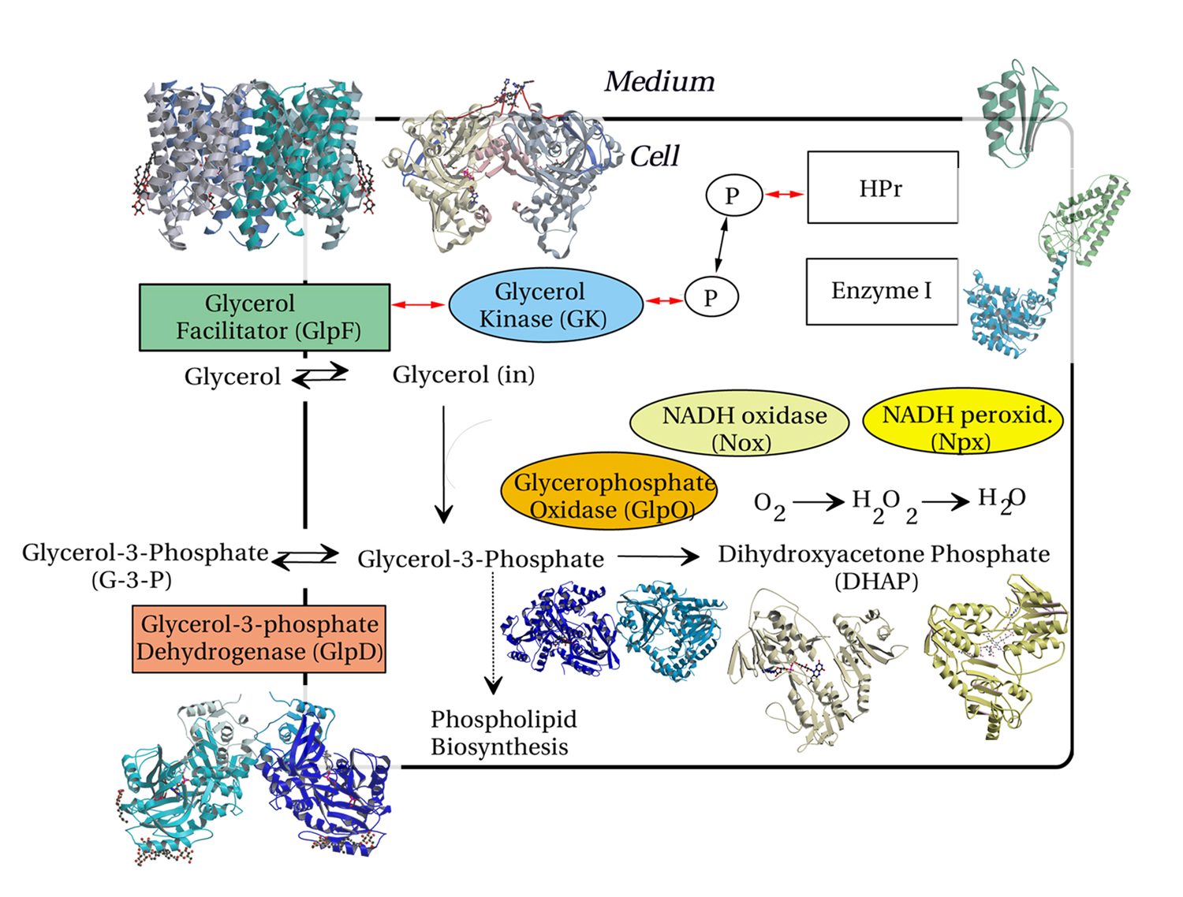

Structure and Biochemistry of Glycerol-3-Phoaphate Dehydrogenase, a Monotopic Membrane Enzyme
Shoucheng Du, Xinmin Li, Unmesh Chinte, Joanne I. Yeh
Department of Structural Biology, University of Pittsburgh Medical School, 3501 5th Avenue, Pittsburgh, Pennsylvania 15260

Sn-glycerol-3-phosphate dehydrogenase (GlpD) is one of the key flavin-linked primary dehydrogenases of the respiratory electron transport chain. An essential membrane enzyme aiding aerobic growth on glycerol, it functions at the nexus of respiration, glycolysis, and phospholipid biosynthesis. GlpD catalyzes the oxidation of sn-glycerol-3-phosphate (G3P) to dihydroxyacetone phosphate (DHAP), with concurrent reduction of flavin adenine dinucleotide (FAD) to FADH₂, and passes electrons on to ubiquinone (UQ) and ultimately to oxygen or nitrate. We had solved the crystal structures of the native enzyme and those complexed with substrate analogues or product, and observed that G3P binds at the re-face of the FAD isoalloxazine ring while the si-face is tightly covered by the protein polypeptide. We propose that Arg-317 or His-233 deprotonates the hydroxyl group of C2 in G3P to initiate dehydration. Then hydride transfer from C2 of G3P to N5 of FAD results in the dihydroflavin anion state. Activity assays of mutations on these two residues showed that deprotonation is one of the crucial steps to the dehydrogenation of G3P by GlpD and Arg-317 is crucial for the deprotonation. The structures of GlpD bound with UQ analogues identify a hydrophobic plateau, 11.6 Å to FAD, as a likely ubiquinone-binding site. Since no other cofactors, metals or metal clusters appear to be required for GlpD activity , we propose that electron transfer from FADH₂ to UQ are mediated through protein residues or through a ping-pong type mechanism whereby the product, DHAP, first exits the cleft, permitting UQ access to FADH₂ for reduction. Our structural and biochemical results provide a basis for addressing further questions about electron-transfer and catalytic mechanisms mediated by this important class of membrane-dependent enzymes. Neutron diffraction studies are also being planned to explore more chemically definitive details of the catalytic pocket and possible electron transfer pathways.
High Resolution with Disordered Systems: Proteins Associated with Lipid Membranes

Mathias Lösche,
Depts. of Physics and Biomedical Engineering, Carnegie Mellon University,
and the NIST Center for Neutron Research

Protein crystallography – and more recently high-resolution NMR – have revolutionized our thinking about cellular processes because of the atomic-scale structural information of proteins and protein-ligand complexes that have become available. However, a large class of proteins is membrane-associated, i.e. such proteins are inserted or interfacially adsorbed to a lipid matrix that is characterized by in-plane fluidity and a large degree of thermal disorder. To study structural characteristics of such membrane-protein systems, the classical high-resolution techniques do not work.

We have engineered membrane mimics, specifically substrate-supported, “tethered” bilayer lipid membranes (stBLMs) that are stabilized by the proximity of a solid-state surface, yet decoupled from the interface by a stable hydration layer. Fluorescence correlation (FCS) shows that their in-plane lipid mobility equals that of free bilayers, although out-of-plane undulations are suppressed by the substrate. Such stBLMs can be used in high-resolution structural studies of membrane-associated proteins using x-ray or neutron scattering. Neutron reflectometry (NR) is a useful tool to determine the structure of such complexes with an out-of-plane resolution of about 1 Ångstrom. This is particularly powerful if solution structures of the proteins from x-ray crystallography or solution NMR are readily available. I will discuss our recent work on the exotoxin, α-hemolysin reconstituted into stBLMs as an example of a membrane-integral protein and of the matrix domain of HIV-1 gag associated with stBLMs as an example of a peripherally associated membrane protein.

PLENARY TALK

Historical perspective on phasing for macromolecular structures
B.C. Wang
Department of Biochemistry and Molecular Biology and SER-CAT, University of Georgia, Athens, GA 30602

The MDS Approach for Data Collection
B.C. Wang¹, Z.J. Liu¹*, L. Chen¹, W. Zhou¹†, H. Xu¹, H. Zhang¹, J.T. Swindell II¹, J.P. Rose¹, G. Rosenbaum¹, Z.-Q. Fu¹, J. Chrzas¹ and M. Benning²
¹Department of Biochemistry and Molecular Biology and SER-CAT, University of Georgia, Athens, GA 30602, ²Bruker AXS, Madison, WI 53711

A fundamental question facing the crystallographer is "For a given X-ray dose, what is the best strategy for collecting a data set from a crystal that will increase structure solvability?" A common answer to this question is to increase the exposure time for each diffraction image, so that we may better “visualize” the recorded reflections to get better data.
Interestingly, we have found that a significantly better data set may be produced for a given crystal and X-ray dose by using shorter exposures (i.e. reduced X-ray dose) and collecting the complete data set multiple times such that the total X-ray dose the crystal receives remains the same. This is the MDS (Multiple-Data-Set) approach.
A highly sensitive X-ray detector can further extend the applicability of MDS approach, as the combination can help to produce a high data redundancy by a single crystal. In a recent case, a total of 8,600 images were collected using the MDS approach, from a single protein crystal with an estimated (visual inspection) diffraction limit of around 2.5Å, using a copper home X-ray source with a highly sensitive detector. The resulting merged and scaled data set gave good statistics to better than 2.0Å resolution. Thus, this unlikely candidate crystal for sulfur phasing has now produced a S-SAD structure from its MDS data collected with a highly sensitive detector.

Both the theoretical and practical aspects of the MDS method as well as the future perspectives of the MDS approach will be discussed.
Work supported by NIH, SER-CAT, University of Georgia Research Foundation, Georgia Research Alliance, and Bruker AXS.

* Current Address: Institute of Biophysics, Chinese Academy of Sciences, Beijing, China
† Current Address: The College of Life Sciences, Nankai University, Tianjin, China.
Human Ribonucleotide Reductase by nucleotide-induced oligomerization

Chris Dealwis
Department of Pharmacology
Case Western Reserve University

Ribonucleotide reductase (RR) is an α_{n}β_{n} (RR1●RR2) complex that maintains balanced dNTP pools by reducing ribonucleoside diphosphates to deoxyribonucleoside diphosphates. RR1 is the catalytic subunit and RR2 houses the free radical required for catalysis. During S-phase, RR is allosterically regulated by its activator ATP and its inhibitor dATP, which regulate RR activity by inducing oligomerization of RR1. Here, we report the first X-ray structures of human RR1 bound to TTP-only, dATP-only, TTP●GDP, TTP●ATP, and TTP●dATP. These structures provide insights into ATP/dATP regulation of RR. At physiological dATP concentrations, RR1 forms mainly hexamers that are inactive. We determined the first X-ray structure of the RR1●dATP hexamer from Saccharomyces cerevisiae, and used single-particle electron microscopy to visualize the α₆●ββ’●dATP holo complex. Site-directed mutagenesis and functional assays confirm that hexamerization is a prerequisite for allosteric inhibition by dATP. Our data provide an elegant mechanism for regulating RR activity by dATP-induced oligomerization.
Diversity in prion protein interfaces revealed by crystallography

Vivien C. Yee¹, Witold K. Surewicz², and Seungjoo Lee¹
Departments of ¹Biochemistry and ²Physiology and Biophysics, Case Western Reserve University, Cleveland, Ohio

Prion diseases, also known as spongiform encephalopathies, are devastating neurological disorders which can be transmitted or inherited, or occur sporadically. The conformational transition of normal cellular prion protein (PrP^{C}) to its pathogenic form (PrP^{Sc}) is believed to be a central event in the development and transmission of prion diseases. A common methionine/valine polymorphism at residue 129 in PrP influences disease susceptibility or phenotype for several human prion diseases. In addition, many point mutants have been identified in familial prion diseases. In order to investigate structural differences between PrP polymorphs and between WT and disease-associated mutants that may contribute to the PrP conformational transition, we have successfully crystallized a number of human PrP variants. These include both of the common Met129 and Val129 polymorphisms and several familial disease mutants. Comparison of these structures with each other and with previously published WT PrP crystal structures reveals different intermolecular interfaces and regions of conformational variability that correlate with the presence of either Met or Val at position 129, or with the presence of a disease-associated mutation. Analysis of the ensemble of PrP crystal structures highlights some structural features which appear to influence the formation and conformation of intermolecular β-sheets involving the polymorphic residue at position 129, and which may contribute to the conformational transition to PrP^{C}, and/or to conformational differences among disease strains.
Structure of Shroom: Development with a twist
Andrew P. Van Demark
Department of Biological Sciences, University of Pittsburgh

The actin-binding protein Shroom is a large multi-domain protein required for a variety of essential developmental processes, including formation of the kidney and gut, retinal morphogenesis, and neural tube formation. It does this by directing the formation of a contractile actomyosin network specifically at the apical surface of a cell. Subsequent contraction then changes a columnar shaped cell into a wedge shaped cell in a process called apical constriction. While Shroom protein sequences are highly variable (~800-2000 residues), they all contain a highly conserved ~300-residue C-terminal domain called SD2 that mediates morphogenic effects through interactions with Rho-associated kinase (Rock).

We have identified a protease-resistant core region within SD2 that is sufficient to interact with Rock and induce apical constriction. This SD2 core region from Drosophila was crystallized and its structure determined at 2.7 Å resolution. The asymmetric unit contains two SD2 dimers, each a three-segmented anti-parallel coiled-coil with a main or body segment (~115Å long) and two arm segments of 60-70 Å attached at either end. Interactions between the chains in all three segments resemble leucine zippers. Interestingly, there is a point of internal symmetry in the middle of the body segment, such that left and right half-dimers overlap with 0.7Å rmsd. The overall arrangement however is asymmetric, and the overall fold appears to be novel.

We have mutated residues within the dimerization interface as well as clusters of highly conserved residues on the dimeric surface of SD2 and examined the ability of these mutants to bind Rock and mediate cytoskeletal changes in vivo. From this analysis we have identified surfaces on SD2 that are important for Rock binding and further shown that SD2 dimerization is required for both Rock binding and cytoskeletal reorganization. From this we are able to propose possible models that describe SD2 function.
Microdiffraction at SER-CAT: an update

John P. Rose, John Chrzas, James Fait, Zheng-Qing Fu, John Gonczy, Zhongmin Jin, Gerold Rosenbaum and B.C. Wang
Southeast Regional Collaborative Access Team, Advanced Photon Source, Argonne National Laboratory and the Department of Biochemistry and Molecular Biology, University of Georgia, Athens, GA 30602.

The Southeast Regional Collaborative Access Team (SER-CAT) has recently installed a Bruker/Maatel MD2 microdiffractometer on its undulator beamline 22ID. The MD2 has been completely integrated into the 22ID beamline control and data collection systems including the Berkeley/ALS automated crystal mounter.

The SERGUI user interface has also been upgraded to incorporate the new futures afforded by the MD2, as well as several user ideas. The current status of the MD2 and its incorporation into SERGUI will be discussed.

Work supported by the members of the Southeast Regional Collaborative Access Team and National Institutes of Health1S10RR25528.
Crystal Structure of the Src-Family Kinase Hck SH3-SH2-Linker Regulatory Region Supports an SH3-Dominant Activation Mechanism
John J. Alvarado¹, Laurie Betts¹, Jamie A. Moroco², Lori Emert-Sedlak²,
Thomas E. Smithgall², and Joanne I. Yeh^{1,3,*}
¹Department of Structural Biology, ² Department of Microbiology and Molecular Genetics, and ³Pittsburgh Center for HIV-Protein Interactions
University of Pittsburgh School of Medicine, Pittsburgh PA 15260.
*Corresponding author jiyeh@pitt.edu

Nearly all-mammalian cell types express multiple members of the Src-family of non-receptor protein-tyrosine kinases, which regulate diverse pathways involved in cell growth, survival, differentiation, adhesion, and migration. Strict control of Src-family kinase (SFK) activity is essential to normal cellular function, and loss of kinase regulation contributes to several forms of cancer and other diseases. The Src family includes eight members: c-Src, Fyn, c-Yes, Lyn, Hck, Lck, Fgr, and Blk. Hematopoietic cell kinase (Hck) is expressed in cells of myeloid lineage and has been implicated in chronic myelogenous leukemia.
Previous X-ray crystal structures of the SFKs c-Src and Hck revealed that intramolecular association of their SH3 domains and SH2-kinase linker regions has a key role in the downregulation of kinase activity. However, the amino acid sequence of the Hck linker represents a suboptimal ligand for the isolated SH3 domain, suggesting that it may form the PPII helical conformation required for SH3 docking only in the context of the intact structure. To test this hypothesis directly, we determined the crystal structure of a truncated Hck protein consisting of the SH2 and SH3 domains plus the linker (Hck32L). Despite the absence of the kinase domain, the structures and relative orientations of the SH2 and SH3 domains in this shorter protein were very similar to those observed in near-full-length, downregulated Hck. However, the SH2-kinase linker adopted a modified topology and failed to engage the SH3 domain. This new structure supports the idea that these non-catalytic regions work together as a “conformational switch" that modulates kinase activity in a manner unique to the SH3 domain and linker topologies present in the intact Hck protein. In support of this idea, we observed that recombinant near-full-length Hck is readily activated by a peptide ligand for the SH3 domain. In contrast, an analogous c-Src protein was completely refractory to activation by the same SH3 ligand, despite its ability to bind to the c-Src SH3 domain. Our results provide fresh structural insight into the facile induction of Hck activity by HIV-1 Nef and other Hck SH3-domain binding proteins, and implicate the existence of innate conformational states unique to individual Src-family members that "fine-tune" their sensitivities to activation by SH3-based ligands.
Crystal structures of a bacterial ligand-gated ion channel co-crystallized with general anesthetics
Jianjun Pan¹, Qiang Chen¹, Christopher B. Divito¹, Ken Yoshida¹, Tommy Tillman¹, Dan Willenbring¹, Jared Sampson², Xiang-Peng Kong², Aina Cohen³, Susan Amara¹, Yan Xu¹, and Pei Tang¹
¹ University of Pittsburgh School of Medicine
² New York University School of Medicine
³Stanford Synchrotron Radiation Lightsource

Gloeobacter violaceus ligand-gated ion channel (GLIC) is the bacterial homologue of nicotine acetylcholine receptors (nAChRs), targets in the central nerve system for general anesthetics. The pH-dependent channel function of GLIC can also be inhibited like the nAChRs by general anesthetics at physiologically relevant concentrations. To understand the mechanism of anesthetic inhibition, crystals of GLIC and the anesthetic ketamine or propofol in the presence of TDM detergent and bacterial lipids were prepared using sitting-drop method at 4ºC. The X-ray diffraction data of GLIC/anesthetic crystals were acquired at Stanford Synchrotron Radiation Lightsource and processed using XDS package. Crystal structures were solved by molecular replacement and refined, using Phenix and Refmac, to a resolution of 2.99Å and 3.19Å for GLIC/ketamine and GLIC/propofol, respectively. To avoid modeling bias, the protein structures were refined alone first before anesthetic molecules were placed into well-defined extra electron densities. Although propofol-binding sites in GLIC could not be determined with the current data, we have identified two ketamine molecules bound to the extracellular domain at the subunit interface, where an amphipathic environment promotes stable binding of the drug molecules. The identified ketamine binding to GLIC is consistent with our results of physiological measurements that ketamine exhibits a strong inhibition effect on GLIC channel function. Our study provides invaluable information for understanding the molecular mechanisms of anesthetic action on the ion channel targets. This work was supported by NIH grants: R01GM066358, R01GM056257, and R37GM049202.

Structural Changes of Ligand-bound Octameric Hemoglobin
Regina D. Kettering¹, Nancy T. Ho², Chien Ho², Michael C. Marsden³ and Joanne I. Yeh^{1,4}
¹Dept. of Structural Biology, University of Pittsburgh, Pittsburgh, PA; ²Dept. of Biological Sciences, Carnegie Mellon University, Pittsburgh, PA; ³INSERM Unité 473, Le Kremlin-Bicêtre, France; ⁴Corresponding Author, jiyeh@pitt.edu
Hemoglobin (Hb) is a tetramer, comprised of two alpha and two beta chains, endowing it with unique thermodynamic properties that are optimized for binding and delivering oxygen. Cooperativity and modulation of oxygen binding affinities are induced through conformational changes that lead to a transition between T and R states. Engineered octameric hemoglobin mutants that link two tetramers via disulfide bridges preserve the cooperativity of human tetrameric hemoglobin while stabilizing the functional tetramer at low protein concentrations. There is much interest in engineering Hb to exploit its oxygen binding properties while conferring desired characteristics such as plasma stability, reversible oxygen binding activity, low toxicity and non-reactivity with other plasma constituents. Previously, Prof. Chien Ho and coworkers designed and biochemically characterized mutant hemoglobins that were shown to be stable octamers with altered biochemical properties (1-2). Our recent structures of these oxidized Hb mutants demostrate novel interactions between monomers that affect the oxygen binding characteristics (3). Cyanide, a diatomic model of oxygen that binds to Hb with 1000-fold higher affinity than oxygen, has been used as a ligand to structurally characterize the oxygen-bound octamers. Unlike other model molecules used in Hb binding, cyanide can bind to the oxidized rather than the reduced form of Hb. Comparison of the earlier oxidized OH-liganded structures with the new cyanomet Hb structures allows identification of the structural changes concomitant with ligand binding, including movement at the ligand binding site. Changes at the disulfide bridge region allow the Hb to crystallize in different space groups, but do not alter the tetrameric quaternary structure. The structural stability of the mutant Hb suggests that the mutation betaGly83Bys stabilizes the R2 quaternary structure over other R state structures, which explains the higher oxygen binding affinity of betaGly83Cys compared to adult human hemoglobin.
1. Fablet C, et al. Protein Sci. (2003) 12:690-5.
2. Vasseur-Godbillon C, et al. FEBS (2006) 273:230-41.
3. Kettering R, S Du, V Baudin-Creuza, MC Marsden, C Ho, and JI Yeh. "Structural Insights on Modulation of Oxygen Binding Properties in Octameric Hemoglobin Proteins - Conformationally-Induced Heme Binding Site Interactions," Submitted.
Structure of an Asymmetric Three-Segmented Coiled-Coil from the Actin-binding Protein Shroom.
Swarna Mohan, Ryan Rizaldy, Jeff Hildebrand and Andrew P. VanDemark
University of Pittsburgh, Department of Biological Sciences

The actin-binding protein Shroom is a large multi-domain protein required for a variety of essential developmental processes, including neural tube closure and retinal morphogenesis. Shroom proteins contain a highly conserved ~300-residue C-terminal domain called SD2 that mediates reorganization of cytoskeletal structure through interactions with Rho-associated kinase (Rock). This SD2-Rock interaction is required for Rock-mediated activation of non-muscle Myosin II which results in the assembly of a contractile actomyosin network. Homologs of known structure have not been identified for either the SD2 or the interacting domain within Rock, and a molecular mechanism that described this regulation has remained unclear.

We present the structure of Drosophila Shroom SD2 (dSD2) at a resolution of 2.7 Å. The structure was determined using single-wavelength anomalous dispersion, and the asymmetric unit contains two SD2 dimers. Each SD2 dimer is a three-segmented anti-parallel coiled-coil with a main or body segment (~115Å long) with an arm segment of 60-70Å attached to each end. Interactions between the chains in all three segments resemble leucine zippers. Interestingly, there is a point of internal symmetry in the middle of the body segment, such that left and right half-dimers overlap with 0.7Å rmsd. The overall arrangement however is asymmetric, and the overall fold appears to be novel.

We have mutated residues within the dimerization interface as well as clusters of highly conserved residues on the dimeric surface of SD2 and examined the ability of these mutants to bind Rock and mediate cytoskeletal changes in vivo. From this analysis we have identified surfaces on SD2 that are important for Rock binding and further shown that SD2 dimerization is required for both Rock binding and cytoskeletal reorganization. For this we are able to proposed several possible models that describe SD2 function.

ββ’ denotes the yeast RR2●RR4 hetero-dimer. While RR2 is a functional β subunit, RR4 (β’) lacks key residues required for producing the free radical.

